BIOL 221 – Concepts of Botany – Fall 2007

Topic 01: Angiosperms

A. Flower and Inflorescence Structure
Angiosperms are also known as the Flowering Plants. They have flowers. Flowers are often arranged into group structures called inflorescences.

A1. The flower
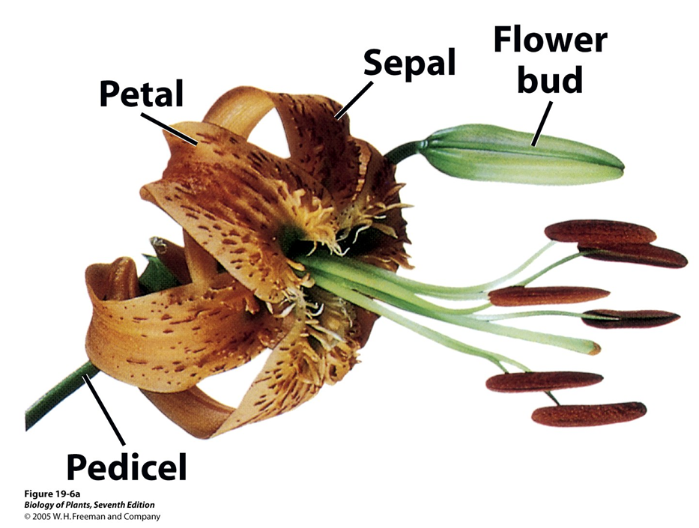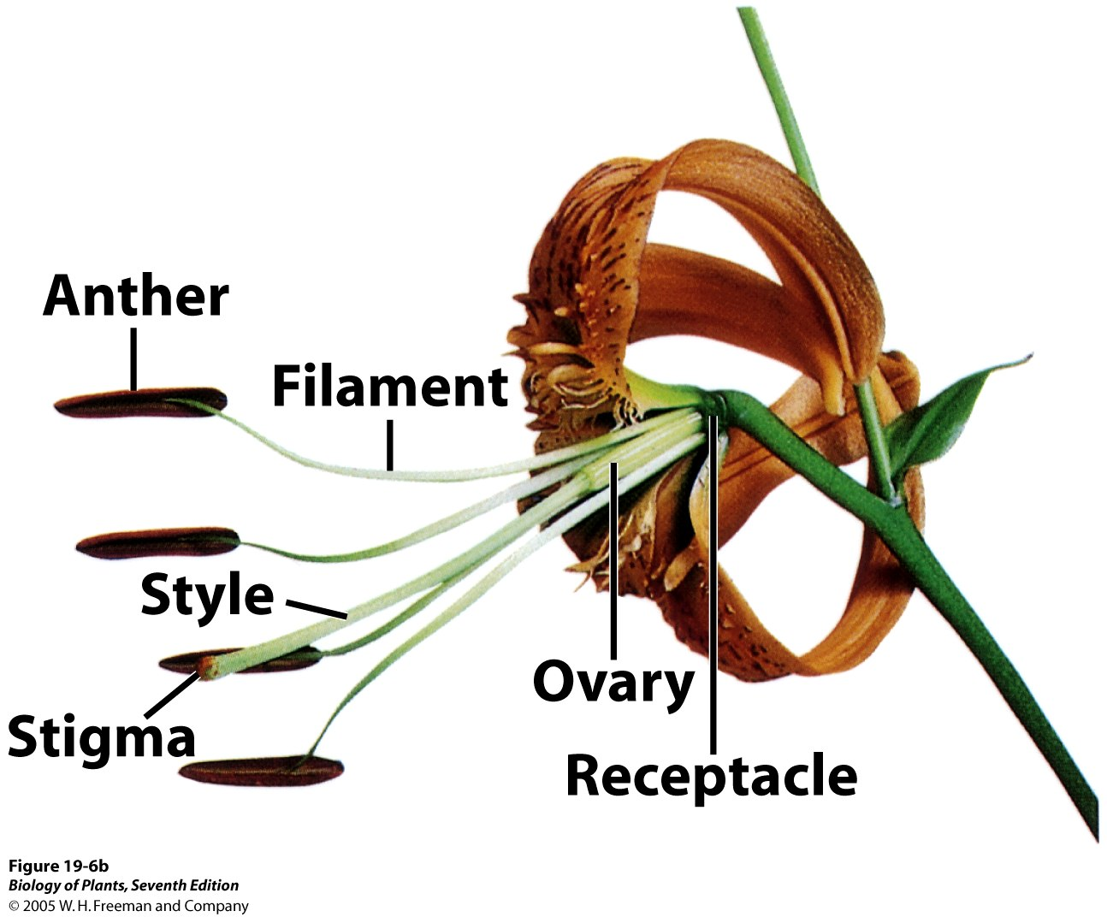

Fig. 1. Basics of flower structure (e.g., lily). Perianth of right flower partially dissected to expose ovary and receptacle.

Sepals are the leafy organs that comprise the outermost whorl called the calyx. The petals are the leafy organs that comprise the next whorl in, the corolla. Collectively, sepals and petals comprise the perianth. The perianth is sterile (i.e., non-fertile) in that they do not bear seeds or pollen.

In many cases, the sepals or the petals are free (i.e., you can discern 3, 4, or 5 separate ones). However, in some species either the sepals, petals, or both are fused to members of their own whorl. For example, hummingbird pollinated flowers typically have their petals fused into a tube (i.e., the corolla is tubular). It is common, however, for such petals or sepals to be only partially fused such that one can still discern the number of petals or sepals by counting the number lobes extending from the particular corolla or calyx tube.

The first fertile whorl is the androecium (with male function) and is made up of stamens. Each stamen is comprised of filament and anther. Pollen is made in the anther.

The second, last, and innermost fertile whorl is the gynoecium (with female function) which is made up of one or more carpels. Carpels are the modified leaves that make up what we call in common language the pistil. There can be more than one pistil per flower. Pistils are often differentiated into ovary, style, and stigma. Ovaries contain the ovules and the placentation (attachment) of these ovules varies with the species (Fig. 2). Ovules will develop into seeds and the ovary will develop into a fruit so it also is possible to determine placentation type from fruits.
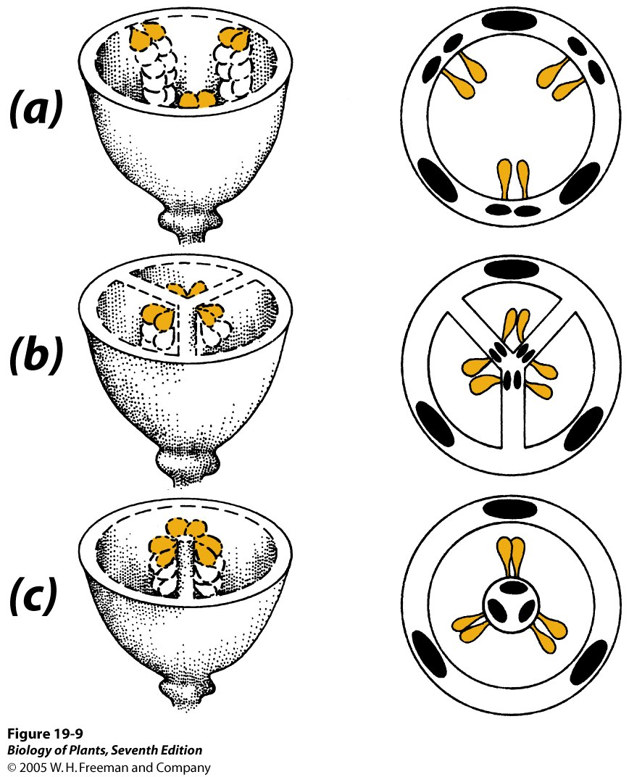
Fig. 2. Placentation types. Cross-sections through ovaries. A, parietal placentation. B, axile placentation. C, free-central.

A2. Flower exercise

We will look at flowers typical of the three major groups of angiosperms: (1) the primitive dicots, from which all other angiosperms evolved, (2) the monocots, which evolved from a lineage of the primitive dicots, and (3) the eudicots, which evolved from another branch of primitive dicots.

The basic distinctions among these three groups are summarized below:

 | Primitive Dicots | Monocots | Eudicots
Cotyledons | 2 | 1 | 2
Leaf venation | reticulate/netted | parallel | reticulate/netted
Floral parts | variable  (often numerous)  to parts in 3’s | in multiples of 3’s | in multiples of 4’s and 5’s
Sepal/Petal  differentiation | poor to lacking | poor to lacking | strong (i.e., sepals green, petals otherwise colored)
Fusion of parts | lacking (i.e., all free) | typically lacking | variable, but many with fused parts.

On a lab bench or outside (INSTRUCTOR’s choice), inspect and answer the following:

St. Johnswort flowers:

These big yellow flowers are a good place to start since all the parts are easy to count.

How many sepals and petals?

Are the sepals and petals differentiated from one another? What color are they?

How many stamens are there?

There is only one pistil here, but because the carpels comprising it are incompletely fused (i.e., there is one ovary but the style is branched), it is easy to determine the number of carpels. How many carpels are there?

Take a razor blade and transversely section the ovary. How many locules (i.e., chambers) are there? Can you discern ovules?

Which of the aforementioned three major groups of angiosperms might this species belong to?

Stonecrop / Crassula:

These white or pinkish flowers are smaller, but the parts should still be easy to count.

How many sepals and petals?

Are the sepals and petals differentiated from one another? What color are they?

How many stamens are there?

How many pistils are there?

How many carpels are there?

Which of the aforementioned three major groups of angiosperms might this species belong to?

Lily Family flowers: Share with a neighbor since we do not have enough lily flowers for everyone.

How many sepals and petals?
Are the sepals and petals differentiated from one another? What color are they?

How many stamens are there?
How many pistils are there?

With the aid of a dissecting scope, transversely section the ovary, count the number of locules and determine the number of carpels this flower has.

Can you see the ovules inside the ovary? What do they look like?

Diagram a higher magnification of the pistil/ovary in cross-section. Identify and label the carpels and the rows of ovules attached to each.

Which of the aforementioned three major groups of angiosperms might this species belong to?

Buttercup Family flowers (e.g., Anemone):

How many sepals and petals?
Are the sepals and petals differentiated from one another? What color are they?

How many stamens are there?
How many pistils are there?

Make a longitudinal median section through the flower and look at the receptacle and the attachments of all the organs. This will give you a good view of the number of carpels/pistils. Use a dissecting scope. Diagram this.

Which of the aforementioned three major groups of angiosperms might this species belong to?

Crapemyrtle (Lagerstroemia) flowers:

How many sepals and petals?
Are the sepals and petals differentiated from one another? What color are they?

How many stamens are there?
How many pistils are there?

With the aid of a dissecting scope, transversely section the ovary, count the number of locules and determine the number of carpels this flower has.

Can you see the ovules inside the ovary? What do they look like?

Diagram a higher magnification of the pistil/ovary in cross-section. Identify and label the carpels and the rows of ovules attached to each.

Which of the aforementioned three major groups of angiosperms might this species belong to?

Butterfly Bush (Buddleja) flowers:

How many sepals and petals?
Are the sepals and petals differentiated from one another? What color are they?

Is there any fusion evident? What parts are fused?

How many stamens are there?
How many pistils are there?

Which of the aforementioned three major groups of angiosperms might this species belong to?

Additional flowers (if available):

Flower species’ name: _______________________

How many sepals and petals?
Are the sepals and petals differentiated from one another? What color are they?
How many stamens are there?
How many pistils are there?

Flower species’ name: ________________________

How many sepals and petals?
Are the sepals and petals differentiated from one another? What color are they?
How many stamens are there?
How many pistils are there?

Flower species’ name: ________________________

How many sepals and petals?
Are the sepals and petals differentiated from one another? What color are they?
How many stamens are there?
How many pistils are there?
A3. The inflorescence
A flower may be borne solitarily or in clusters or groups called INFLORESCENCES. Either each flower or the entire inflorescence, or both, may be subtended by one or more leaves, which if modified in shape, size, or appearance is (are) called BRACT(S).

Developmentally, subtending bracts (and leaves) and flowers are related because the flower is technically an axillary shoot (i.e., a branch), and branch buds always are produced above leaves.

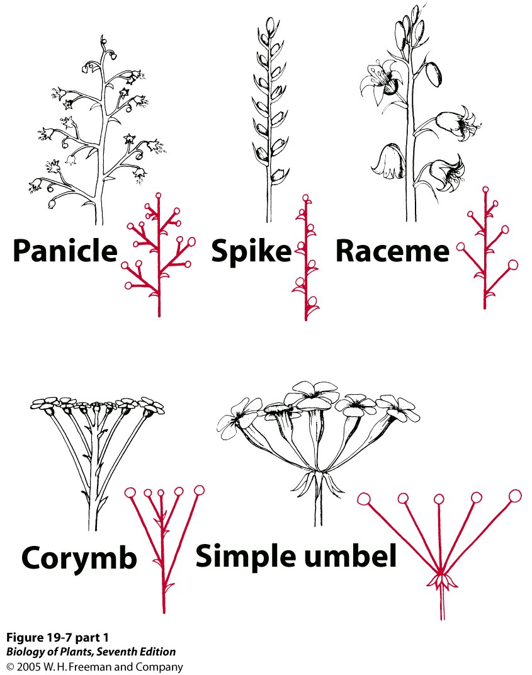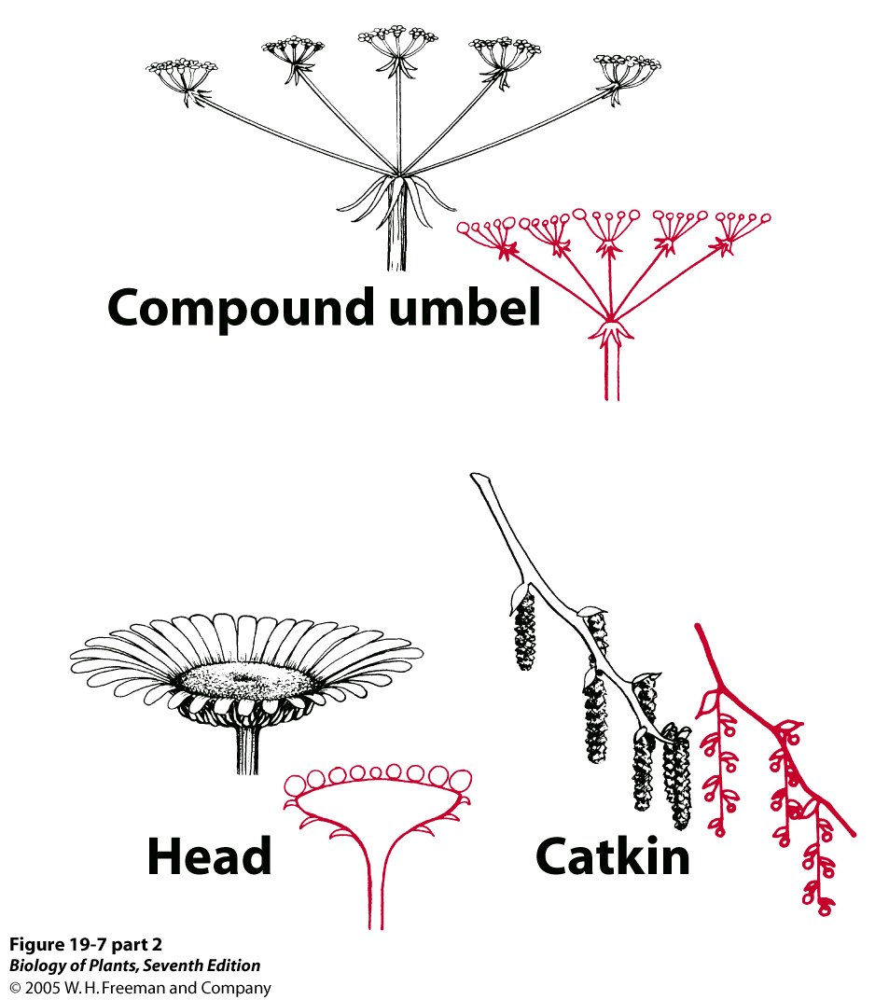

Fig. 3. Some types of inflorescences.

INSTRUCTOR’s CHOICE: Review the inflorescences on the lab bench or at the back of the room. The plants are chosen because their inflorescence type characterizes the plant family to which they belong.

Plant Family Name:__________________ Infl. Type: _______________________

Plant Family Name:__________________ Infl. Type: _______________________

Plant Family Name:__________________ Infl. Type: _______________________

Plant Family Name:__________________ Infl. Type: _______________________

Plant Family Name:__________________ Infl. Type: _______________________

Plant Family Name:__________________ Infl. Type: _______________________
B. Fruits
Angiosperms not only have flowers, but also fruits.
A fruit develops from the ovary, after pollination and fertilization has been achieved.
Thus, the ovary wall becomes the fruit wall and flesh, the ovules of the ovary become the seeds.

Thus, the ovary (fruit) wall is the vessel that contains the ovules (seeds). In fact, angio is greek for “vessel”, and sperm means “seed”.

Various fruits are available for you to look at. Using the posters on the wall and the key provided in the back of this lab manual, identify the types (classes) of fruit represented by the following:

Fruit Species Name | Fruit Type

C. INSTRUCTOR’s choice: Some Important Angiosperm Families
Here are some important angiosperm families. Compare and contrast them based on the material at hand.

Dicots

1. Pea & Bean family (Fabaceae or Leguminosae)

2. Maple family (Aceraceae)

3. Oak, Beech, & Chestnut family (Fagaceae)

4. Sunflower, Aster, or Composite family (Asteraceae or Compositae)

Monocots

5. Orchid family (Orchidaceae)

6. Palm family (Arecaceae or Palmae)

7. Grass family (Poaceae or Gramineae)
A Key to Common Fruit Types

I. SIMPLE FRUIT—develops from the single ovary of one flower.
A. SIMPLE DRY FRUIT—pericarp becomes leathery, papery, or woody.
1. DEHISCENT—opens when ripe.
a. FOLLICLE—develops from a simple pistil, opens along one side only. b. LEGUME—from a simple pistil, opens along two sides.
c. CAPSULE—from a compound pistil (i.e., one with two or more carpels). Opens in a variety of ways.
d. SILIQUE—from a single pistil, the lateral walls of the flattened fruit opening, leaving behind the seeds attached to a persistent, free-standing partition. Members of the mustard family.
2. INDEHISCENT—fruit does not open at maturity.
a. ACHENE (expanded here to include the “cypsela” of the sunflower family)—small, one-seeded; seed coat free from pericarp.
b. GRAIN or CARYOPSIS—seed coat is fused with pericarp. Members of grass family. c. SAMARA—usually one-seeded, has a wing formed by an extension of the ovary wall. (see SCHIZOCARP for maple).
d. SCHIZOCARP—fruit breaks into 1-carpellate seeded units with the seeds inside.
Sometimes schizocarps are wing-shaped and are thus called SAMAROID SCHIZOCARP.
d. NUT—a rather large, hard-walled, 1-2-seeded fruit. Bracts usually wholly or partially enclose the hard pericarp.
B. SIMPLE FLESHY FRUIT—a portion or all of the pericarp is fleshy at maturity.
1. BERRY—entire pericarp fleshy.
a. REGULAR BERRY
b. “HESPERIDIUM”—a special type of berry in which the pericarp is leathery, and the inner wall of the carpels has extra-plump and juicy trichomes (fruits of the citrus family).
c. “PEPO”—this term is often applied to special berries of members of a certain well known family. The pericarp is leathery or rind-like.
2. DRUPE—pericarp divided into three parts: outer EXOCARP (the “skin”), middle MESOCARP (usu. fleshy, sometimes fibrous), and inner ENDOCARP (which is stony). The stony endocarp or “pit” encloses the seed.
3. SIMPLE ACCESSORY FRUIT—fruit includes ovary wall and other floral parts or nearby structures.
a. POME—from an inferior ovary of some members of the rose family (e.g., apples and pears): the receptacle or floral tube in which the ovary was embedded becomes fleshy, along with the exocarp and mesocarp. The endocarp is leathery.
II. AGGREGATE FRUIT—develops from a number of separate ovaries of one flower. The component fruit-propers are called “fruitlets”.
A. raspberry—simple fruits are drupes (drupelets), and these adhere to one another and together separate from the dry receptacle.
B. AGGREGATE ACCESSORY FRUIT—receptacle is incorporated into the “fruit”.
1. Blackberry—drupelets adhere to elongate, fleshy receptacle.
2. Strawberry—simple pistils ripen into achenes on fleshy, greatly enlarged receptacle.
3. Magnolia—simple pistils, each developing into a follicle, and becoming partially fused to one another along with the elongate receptacle to which the pistils are attached.
III. MULTIPLE FRUIT—develops from a number of individual ovaries of flowers grouped closely together in an inflorescence. A fruit is produced from each flower, and these fruits remain together (or even fuse) in a single mass.

