BIOL 221 – Concepts of Botany

Topic 02: Gymnosperms + Seed and Pollen Basics

A. General Objectives for today’s lab .

1. Compare and contrast the gymnosperms with the angiosperms.

2. Become familiar with the major groups of gymnosperms (one of which is the Conifers).

3. Learn to use a dichotomous key to conifer genera.

4. Learn the basic structure of the seed and pollen as a synapomorphy of the seed plants.

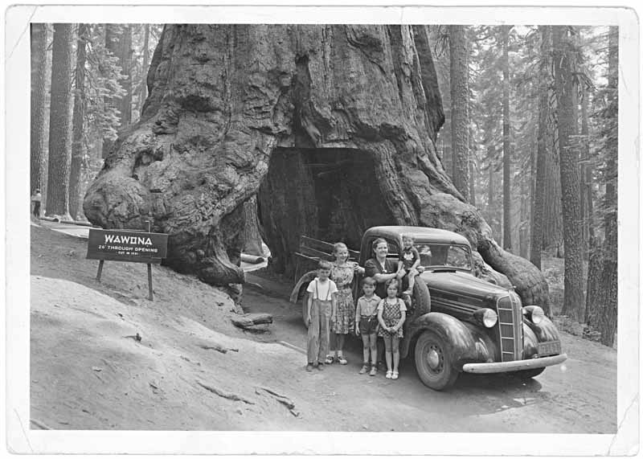
Sequoiadendron giganteum (giant redwood)
B. Seeds and Pollen .
The unit of dispersal in seed plants is the seed.

1. The seed consists of three important parts:

1. An embryo (a genetically unique embryonic plant, produced through sexual reproduction).
2. The seed coat (the outer, protective layer of the seed).
3. Some form of nutritive tissue (to nourish the developing seedling, upon germination).

In gymnosperms, this nutritive tissue is megagametophyte tissue. In angiosperms, it is triploid endosperm which is made possible by “double fertilization”.

A seed develops from an ovule. An immature ovule consists of the following:

1. The diploid megasporangium (also called the nucellus in the seed plants). This produces haploid megaspores via meiosis.
2. An integument (or two). This is an outer protective structure.

A mature ovule consists of the following.

1. The megagametophyte (a multicellular, haploid organism that produces the egg cell(s)). The megagametophyte develops via mitosis from one of the megaspores produced previously via meiosis.
2. An integument (or two). This is an outer protective structure.

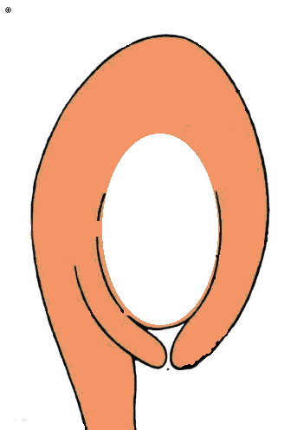
megaspore mother cell.
megasporangium
immature ovule
integument
micropyle

Investigate seed structure in Capsella, the shepard’s purse. This is an angiosperm so note that the seeds are contained within a fruit.

Draw and label the following:

Seed coat, the embryo with two cotyledons (this is a dicotyledonous angiosperm), endosperm nutritive tissue.

2. Like the seed, pollen is unique to the seed plants. It represents the protective vehicle for transporting sperm directly to the egg of the megagametophyte. Thus, sperm no longer have to swim through water to reach the egg as it did in more primitive plants; instead, they are delivered by wind, bee, bird, and then pollen tube. Technically speaking, the pollen is the microgametophyte.

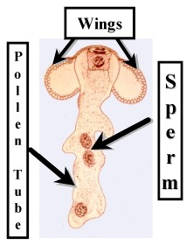
Above, the mature microgametophyte of a pines: germinating pollen grain (pollen-tube contains two sperm cells). The wings are peculiar to pine pollen and are not characteristic of pollen in general.

Like all gametophytes, the pollen develops from a spore. In this case, these are called microspores.

Investigate pollen using the compound microscope. Make drawings.

Slides available for this are:
1. Mixed Pollen Types

2. Lily anther x-sections.

3. Pollen tubes.

C. Gymnosperms .

C1. The four major groups of gymnosperms .
Cycadophyta (cycads) – Cycas, Zamia.
Ginkgophyta (maiden-hair tree) – Ginkgo biloba
Gnetophyta (Gnetum & friends) – Gnetum, Ephedra, & Welwitschia.
Coniferophyta (conifers) – Pinus (pine), Sequoia (redwood), Abies (fir) and many other genera.

Learn to distinguish between conifers, ginkgos, and cycads.

C2. Gymnosperm seeds are “naked”.
In the conifers, the seeds are naked in cones. This contrasts with fruits of angiosperms, with surround and envelope the seeds.

Inspect the various cones for seeds at your table for seeds.

C3. Gymnosperms male strobili (e.g., Zamia).

With the microscope, study the male (“staminate”) strobilus x-section prepared slide. Note the microsporangia on the sporophylls of the strobilus, with pollen in them. This whole strobilus is analogous to the androecium of the flower in angiosperms.

Compare this to the real strobilus.

C4. SPRING SEMESTER ONLY: Gymnosperm wood has only tracheids, no vessels.

Inspect the prepared slides of conifer wood.

First, there are conspicuous resin ducts/canals.
This is peculiar to conifer wood and is responsible for their fragrant, piney smell.

Secondly, after the resin ducts, the wood is very homogeneous, that’s because it consists primarily of tracheids and has no vessel elements.

C5. Conifers do not have ovulate (female) strobili, but “CONES”. Cones are actually compound branch structures. The cone scales with ovules on them are subtended by bracts. In most other gymnosperms, ovules are borne on sporophylls of female strobili.

Prepared Slide: Compare and contrast a male strobilus with a female cone in Pinus (a conifer).

D. Key to conifer genera .
A key is a tool for identification. Attached to the back of this lab write-up are a key to conifer genera on MU campus, along with an illustrated glossary with terms you will need for the key.

Key out the conifer genera present in the room or that you come across outside on an outing (INSTRUCTOR’s choice). Record your answers below.

1.

2.

3.

4.

5.

6.

7.

8.

9.

10.

11.

12.

13.

14.

A. Plants not evergreen
B. Branchlets short and stubby, persistent, alternate.......................................Larix, Larch
BB. Branchlets elongate, deciduous, opposite.....................Metasequoia, Dawn Redwood
AA. Plants evergreen
C. Leaves needle-shaped or otherwise elongate and well-diverging from the stem
D. Leaves in fascicles of 2, 3, or 5.........................................................Pinus, Pine
DD. Leaves borne singly or tufted on stubby side-branches (but not fascicled)
E. Leaves tufted on stubby side-branches.......................... . Cedrus, Cedar
EE. Leaves borne singly
F. Leaf ending at stem, so stem is woody in texture and color.
G. Leaves sharp-pointed and square in cross-section, with small woody peg-like leaf-stalk.................... Picea, Spruce
GG. Leaves round-pointed and flattened, woody peg-like leaf-stalk absent or if present not very prominent
H. Leaves usually <1.25 cm long, with distinct leaf- stalk; cones 1-2 cm long ...............Tsuga, Hemlock
HH. Leaves >1.5 cm long, with no distinct leaf- stalk (although perhaps with a gradually narrowed leaf-base); cones >2.5 cm long
I. Cones erect with scales deciduous at maturity; needle-base swollen and round, leaving a round leaf-scar...............Abies, Fir
II. Cones pendulous, scales persistent, with very long 3-lobed bractsthat look like the rear-end of a mouse; needle-base not swollen, leaf-scar either not round or not very big...............Pseudotsuga, Douglas Fir
FF. Leaf-base decurrent along (i.e., the base runs along) the stem for some distance, such that twig stem to which leaves are attached appears green.
J. Leaves flattened and round pointed; cones with just a single seed which is partially enclosed in fleshy red aril; often bushes or shrubs.......................................Taxus, Yew
JJ. Leaves angular (not flattened) in cross-section and pointy; cones round and larger (> 1 cm diameter) and with more than one seed and no fleshy aril; trees .............................................Cryptomeria, Japanese Cedar
CC. Leaves scale-like (or at least not especially elongate)
K. Branchlets forming flattened fan-like sprays
L. Twiglets much flattened; cones elongate; cone-scales flattened, 8-12 ..................................................Thuja, Arbor Vitae
LL. Twiglets rounder; cones round; cone-scales shield-shaped, 4- 8................................................................Chamaecyparis, Cypress
KK. Branchlets forming 3-D clusters not at all fan-like
M. Cones soft and berry-like, needle leaves (juvenile) and scale leaves (adult) often mixed.........................................................Juniperus, Juniper
MM. Cones woody
N. Cones < 0.5 cm; leaves uniformly scale-like and <2 mm long..........Cupressus, Cypress
NN. Cones >0.5 cm; leaves longer (>2 mm long)........Cryptomeria
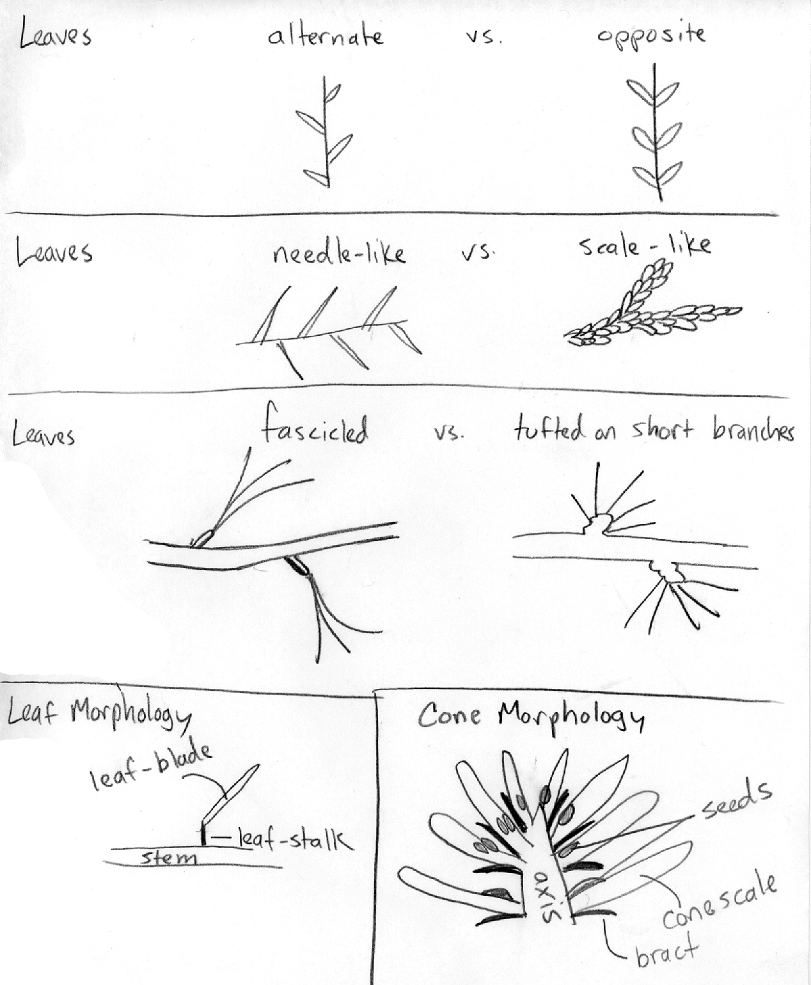
Illustrated glossary for help with conifer key.

